**User Manual**

Welcome to Fraction Runner, an educational running game!

In this game, the object is to see how long you can stay alive.

Upon start, the player is asked to write a number.

The game puts player’s number in a fraction as the numerator over the same number of 9s in denominator.

(Example: 443 becomes 443/999)

The division produces a string of repeating decimals which will be displayed as the ground.

(From our earlier example: 443/999 becomes 0.443443443...)

The player runs on top of the numbers using Jump, Duck, or Attack to stay alive.

The player that stays alive the longest time is the winner.

When running, check out the repeating decimals.

On the Home Screen you will see three choices:

Fraction Runner – select when you are ready to begin the game

Introduction Page – click to learn more about the game and its developers

Top 100 Scoreboard – pick this to see who has the high score

Player will log in on the Log in Page:

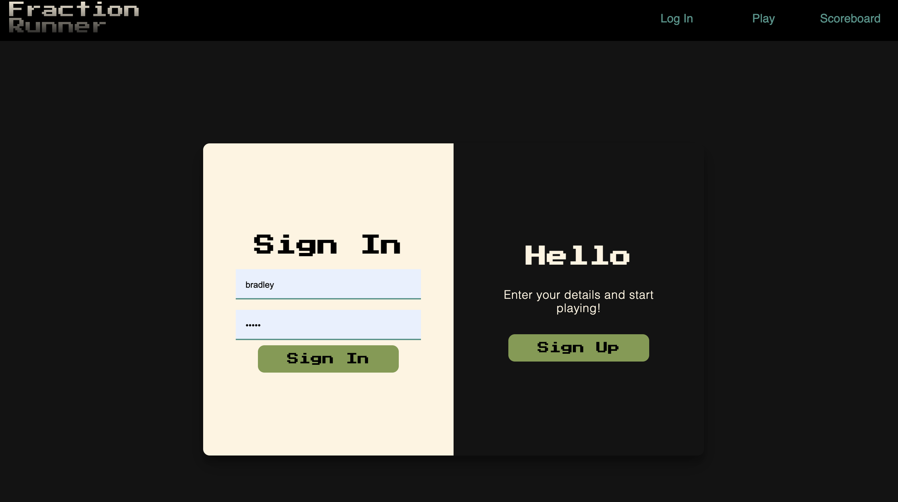

Controls:

Each character can perform three different actions:

*Jump – press the up arrow

*Attack – hit the attack button

*Duck – press the down arrow

(Screenshot of character needing to duck)

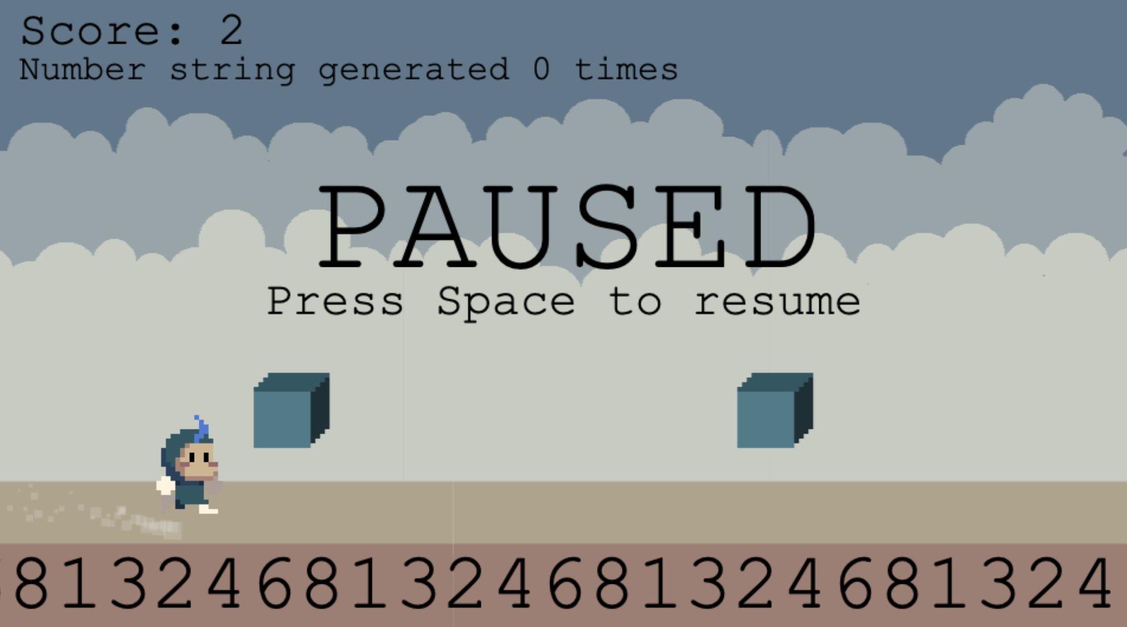

Gameplay:

At the start, the player is asked to select a character.

There is no skill difference between the characters.

When starting the game, the player must pick a number up to 999,999,999.

After entering the number, the running game begins.

(Screenshot of character jumping over an obstacle)

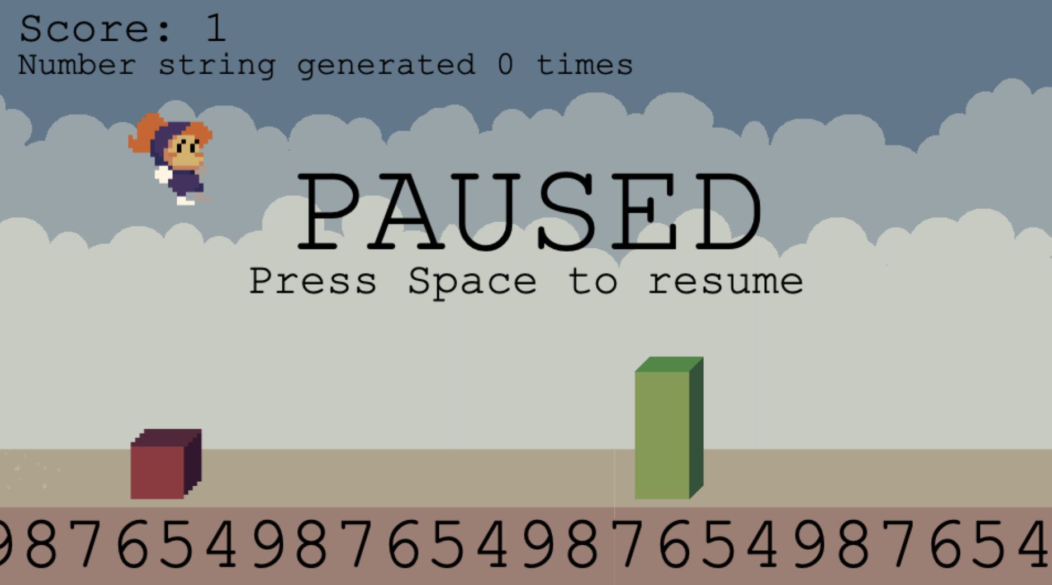

The object of the game is to see how long the player can stay alive.

The timer starts at the beginning of the game.

Once the player has been hit by an object, the game is over.

The time is calculated and added to the Scoreboard.

Fraction Runner Scoreboard:

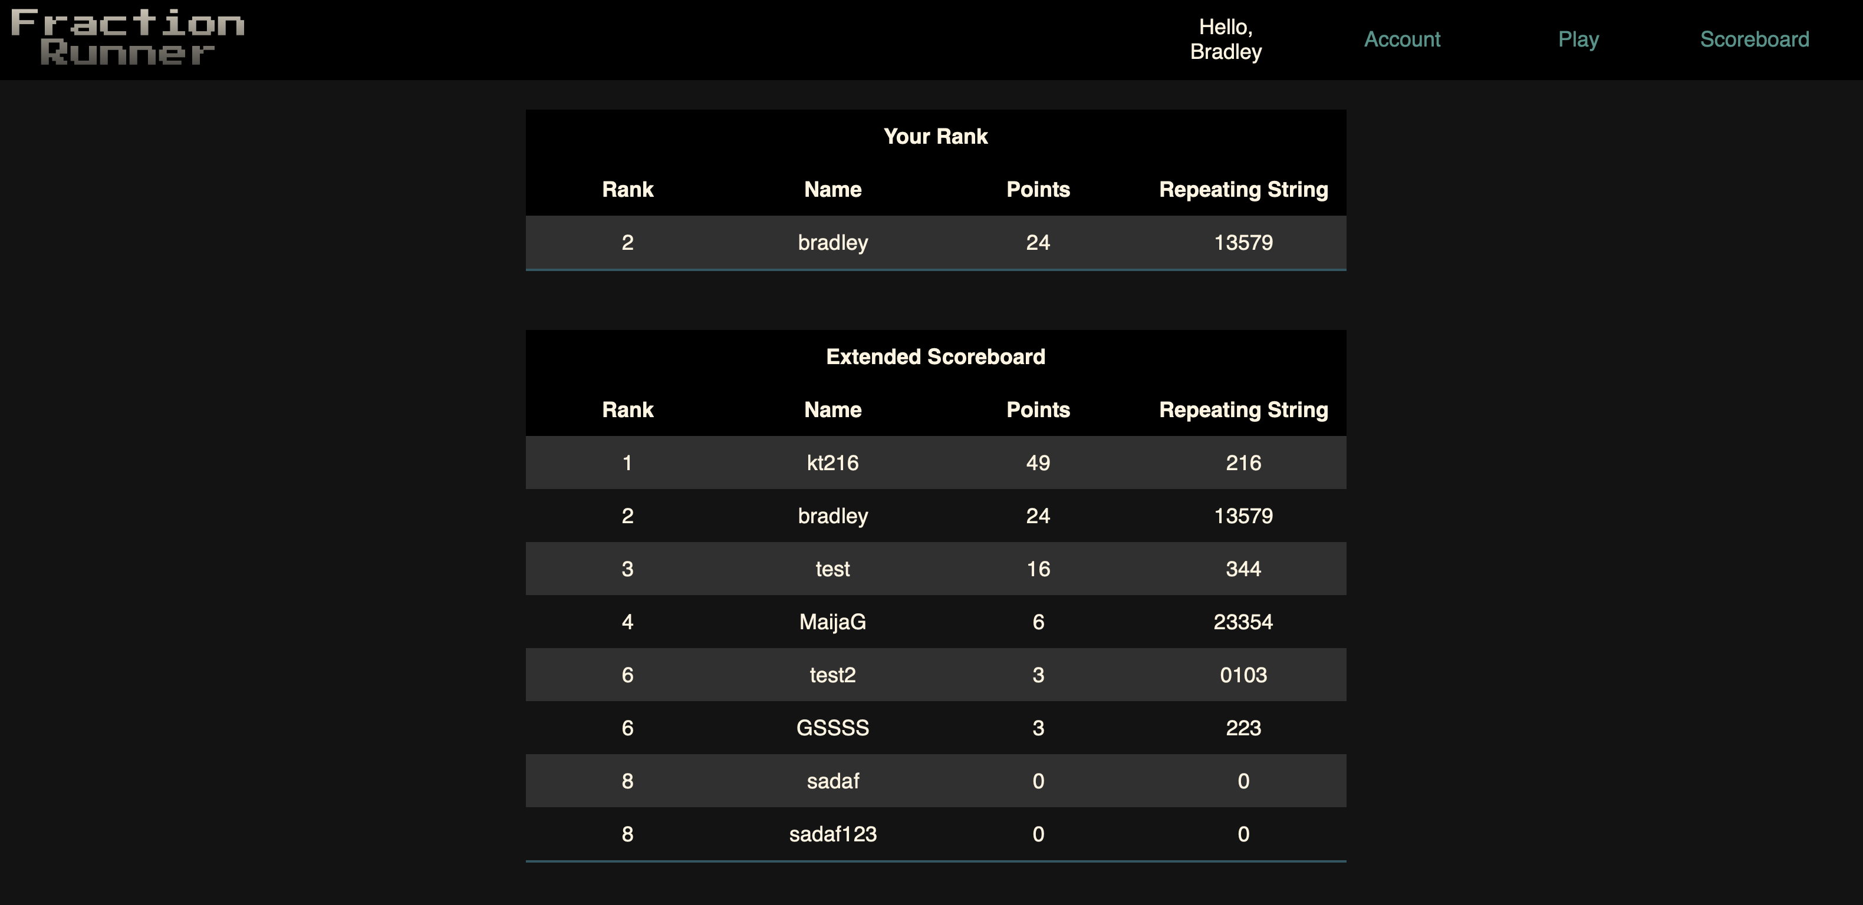

Tips and Tricks:

*There are three different obstacles. Each one can only be defeated by the correct action.

*Use Jump when a red obstacle appears

*Use Duck to go under the blue block

*Use Attack to break a green wall

*The runner will speed up as time continues. Stay alert!

We Thank you for playing Fraction Runner.